

CHMB31H3
Introduction to Inorganic Chemistry
Term test 1

October 24, 2016

Candidate Form
Before you begin your examination, please fill out this form and leave it at the side of your desk along with your student I.D. Please sign at time of collection.

Room # ________________________ Seat # (if assigned) _________

Name (please print):__________________________________________________________
Surname Given Names

Student Number:

Course: __CHMB31H3__ Instructor’s Name: __Alen Hadzovic________

Signature: ________________________________________________
(sign only at time form is collected)

CHMB31H3 – Introduction to Inorganic Chemistry
Term test 1

October 6, 2014

Answer all questions in full.
Value of each question is indicated. Total is 83 marks.
Aids Allowed: Appendix and Periodic Table of Elements both are provided at the back
Non-programmable calculator

Please, read each question carefully and make sure you have indeed answered every part of each question!!!

Duration: 90 min (1.5 h)

GOOD LUCK!!

Student Name: ___________________

Student Number: _________________

- (12 marks) Fill in the blanks to complete the definitions:

  - In terms of stability of atomic nucleus, the equation ΔE = Δmc² defines __nuclear binding energy_____ (3 words).
  - The first ionization potential is energy required to __ remove __ (1 word) an electron from an atom in ___ gas __ (1 word) phase.
  - All atoms with the same number of protons in their __ nucleus __ (1 word) constitute a _____chemical element____ . (2 words)
  - The effective nuclear charge __increases__ (1 word) from left to right in the periodic table.
  - A reaction is spontaneous if its Gibbs energy is _ negative __ . (1 word)
  - Brønsted acids are proton _ donors__. (1 word)
  - Oxidizing reagent is electron _ acceptor _ . (1 word)
- (4 marks) Find the missing nuclides/particles (marked with X):
  - ²³Mg → ²³Na + X
  - ²H + ¹⁴N → ³He + X
  - ²³⁵U + n → X
  - X + ²¹Ne → ²²Na + ¹¹B
Answer:
a. e⁺ or β⁺ b. ¹³C

c. ²³⁶U d. ¹²C

- When discussing atomic orbitals, we frequently mentioned ‘nodes.’
  - (2 marks) What are atomic orbital nodes?
  - (2 marks) What two types of atomic orbital nodes we mentioned?
  - (1 mark) Which atomic orbital has no nodes (being very specific is the key here!)?
(Answer space on the next page!)
Answer:
a. A node is a location at witch the value of the wave function is zero. (Or: A location at which the probability of finding an electron is zero)
b. angular nodes and radial nodes

c. 1s orbital

- (4 marks) Explain the decrease in atomic size across the period (from left to right) in the periodic table.
Answer:
From left to right the additional electron goes into the same electronic shell (same principal quantum number) while the effective nuclear charge is increasing in the same direction. Increase in the Z_{eff} contracts the valence shell and the atoms become smaller.

  - (4 marks) Calculate Z_{eff} for a 3p electron in sulfur atom (show full calculation, not only the final result).
  - (2 marks) Based on calculated Z_{eff} calculate the first ionization potential for S atom.
Answer:
a.
(1s²) (2s²2p⁶) (3s²3p⁴)
σ = 0.35 × 5 + 0.85 × 8 + 1.00 × 2 = 10.55
Z_{eff} = Z – σ = 16 – 10.55 = 5.45

b. $I_{1}=\frac{1312.1\frac{kJ}{mol}×Z_{eff}^{2}}{n^{2}}=\frac{1312.1\frac{kJ}{mol}×{5.45}^{2}}{3^{2}}=4330.3\frac{kJ}{mol}$

- Consider BrCl₃ molecule.
  - (3 marks) Draw a clear Lewis dot structure of this molecule
  - (2 marks) What are (a) electron and (b) molecular geometries of BrCl₃.
  - (1 mark) Draw a clear structure of BrCl₃.
  - (1 mark) What is the hybridization on the central atom in this molecule?
Answer:
a. Lewis dot structure | b.  electron geometry is: _trigonal bipyramid___  molecular geometry is: _ T–shaped___
c. BrCl₃ structure: | d.  Hybridization on the central atom is:  sp³d

- (10 marks) Draw a clear molecular orbital diagram for a hypothetical HC molecule (one hydrogen and one carbon atom). Calculate the bond order and state if the molecule could exist.
Answer:

- (5 marks) Identify Lewis acid and Lewis base in the following equilibrium reaction:
CO₂ + OH– HCO₃–
- Write the equation for the equilibrium constant for this reaction.
- To which direction (left or right) would equilibrium shift if more base is added? Explain.
Answer:
Lewis acid is CO₂, Lewis base is OH–.
$$K=\frac{\left[HCO_{3}^{-}\right]}{\left[CO_{2}\right]\left[OH^{-}\right]}$$

If more base is added, the equilibrium shifts to the right. Increasing the concentration of

- (5 marks) Identify acidic and basic oxides in the table below
Oxide | Acidic or basic?!
KO₂ | basic
Cl₂O₃ | acidic
I₂O₇ | acidic
MnO | basic
NO₂ | acidic

- Consider the following redox reaction that takes place in a basic aqueous solution:
Cr³⁺ + BrO₃– + H₂O → CrO₄^{2–} + Br– + H⁺
  - (4 marks) Write balanced half reactions (e.i. reduction half-reaction and oxidation half-reaction)
  - (2 marks) Balance the redox reaction
  - (3 marks) Determine if the reaction is spontaneous as written above, if the reduction potentials under basic conditions are $E_{BrO_{3}^{-}, Br^{-}}$= + 0.584 V and $E_{CrO_{4},Cr^{3+}}$= –0.11 V.
  - (3 marks) Find the missing potential in the Latimer diagram for bromine under basic conditions:
(Answer on the next page!)
Answer:
a.
Cr³⁺ + 4H₂O – 3e– → CrO₄^{2–} + 8H⁺ or Cr³⁺ + 8OH– – 3e– → CrO₄^{2–} + 4H₂O
BrO₃– + 6H⁺ + 6e– → Br– + 3H₂O or BrO₃– + 3H₂O + 6e– → Br– + 6OH–

b.
2Cr³⁺ + BrO₃– + 5H₂O → 2CrO₄^{2–} + Br– + 10H⁺

c.
E_{cell} = +0.584 V – (-0.11 V) = +0.694 V
Since E_{cell} > 0, ΔG must be < 0 and the reaction is spontaneous.

d.
$$E^{0}=\frac{1×0.455V+1×1.065 V}{1+1}=0.76V$$

- The lattice energy of NaBF₄ is –657 kJ mol^{–1}. This ionic compound contains tetrahedral BF₄– anion. The radius of sodium cation is 0.102 nm.
  - (3 marks) Using Kapustinskii’s equation, calculate the thermodynamic radius of BF₄– anion.
  - (2 marks) Using this calculated radius for BF₄– and known radius of Na⁺, predict the most likely structure for NaBF₄.
Answer:
a.
$$-657\frac{kJ}{mol}=-\frac{1.07×{10}^{5}×2×1×1}{102pm+r_{-}}\frac{kJ×pm}{mol}$$
$$67014\frac{kJ×pm}{mol}+657\frac{kJ}{mol}r_{-} =2.14×{10}^{5}\frac{kJ×pm}{mol}$$

$$r_{-} =\frac{2.14×{10}^{5}\frac{kJ×pm}{mol}-67014\frac{kJ×pm}{mol}}{657\frac{kJ}{mol}}=223.7pm$$
b.
$$ρ=\frac{r_{small}}{r_{large}}=\frac{102pm}{223.7pm}=0.456$$
The lattice type is NaCl

- (2 marks) What does it mean when we say that “The coordination number of Cs⁺ in CsCl is 8” ?
Answer:
It means that each Cs⁺ cation is surrounded by eight neighboring Cl– anions.

- (4 marks) Give two reasons (each a. and b.) for:
  - Placing hydrogen in Group 1
  - Placing hydrogen in Group 17
Answer:
a.
Hydrogen belongs to group 1 because it (1) readily forms a +1 cation (2) it has 1s¹ electronic configuration.

b.
Hydrogen belongs to group 1 because (1) it is a non-metal and (2) it forms H₂ (diatomic) molecule.

- (2 marks) What is syn gas? What is it used for?
Answer:
Syn gas is a mixture of CO and H₂ gases. It is used in H₂ production and methanol synthesis.

- END OF TEST -
APENDIX: Formulae, tables and plots

$I_{1}=\frac{1312.1\frac{kJ}{mol}×Z_{eff}^{2}}{n^{2}}$ $ΔH_{latt}=-\frac{1.07×{10}^{5}×ν×\left|z_{+}\right|\left|z_{-}\right|}{r_{+}+r_{-}}\frac{kJ×pm}{mol}$ $E^{0}=\frac{n_{A}E_{A}^{0}+n_{B}E_{B}^{0}+…}{n_{A}+n_{B}+…}$

Valence orbital energies
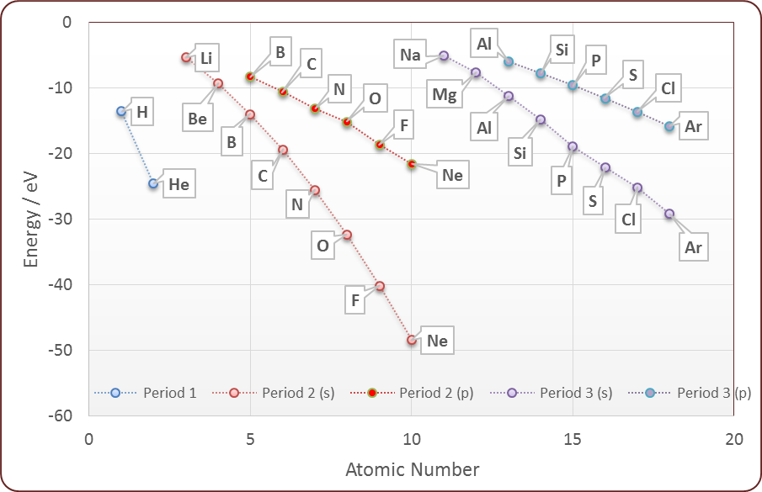

Hybridization schemes for electron geometries
(listed as arrangements”)
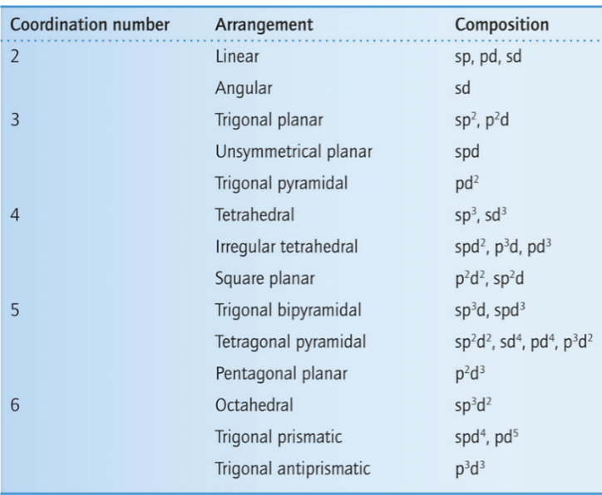
Ratios for structure types:

Ratio range | AB type | AB₂ type
0.732 – 1 | CsCl | CaF₂
0.414 – 0.732 | NaCl | TiO₂
0.225 – 0.414 | ZnS

